**ZC-G52-ITX6412 Fanless Industrial PC Onboard Intel Elkhart Lake J6412 CPU 4 Cores 2.0GHz Burst to 2.6GHz Intel UHD**

**Graphics With 4*USB 2.0,2*USB 3.0,4*RS232,2*RS232/422/485,1*VGA,1*HDMI,2*LAN Ports,1*MIC,1*SPK**

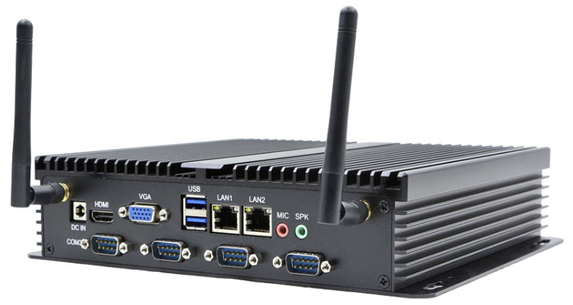

**Main Features:**

1) Onboard Intel Elkhart Lake J6412 4 Cores 2.0GHz Burst to 2.6GHz.

2) Intel Intel UHD Graphics Card,Support 4K

3) With 1*VGA Ports,1*HDMI,Support Double Display

4) Rich USB Ports,Support total 6*USB Ports

5) Rich COM Ports,Support 4*RS232+2*RS232/422/485

6) Onboard 2*Realtek RTL8111H Gigabit,Suppot PXE/Wake on LAN

7) Full aluminium alloy shell,dustproof,durable,resist compression

8) Fanless Design,Industrial Design,Best Quality,Cheap Price

9) mPCIE for WIFI/3G/4G module,1*SIM Slot

**ZC-G52-ITX6412 Fanless Industrial Computer Specification**

|  |  |
| --- | --- |
| **CPU** | Intel Elkhart Lake J6412,4 Cores 2.0GHz Burst to 2.6GHz,TDP 10W |
| **RAM** | 1*DDR4 SO-DIMM |
| **Storage** | 1*M.2 Key M Support NVME/SATA SSD |
| 1*2.5’’ Slot |
| **Graphics Card** | Intel UHD Graphics,Support 4K |
| **Network Card** | 2*Realtek RTL8111H Gigabit |
| Support Wake On LAN,PXE |
| **I/O Ports** | 1*VGA  1*HDMI  4*USB 2.0  2*USB 3.0  1*Audio Out  1*MIC In  2*RJ45  4*RS232  2*RS232/422/485  1*DC Jack  1*Power Button  2*Antenna Holes |
| **Expand** | mPCIE for WIFI/3G/4G module  1*Sim Slot |
| **Size** | 52*215*236mm |
| **Weight** | 1.85KG |
| **Power Supply** | DC12V |
| 9-36V (Optional) |
| **Working Temperature** | -10℃~+60℃ |
| **Storage Temperature** | -20℃~+70℃ |
| **Relative Humidity** | 5%-95% Relative humidity,no condensation |

